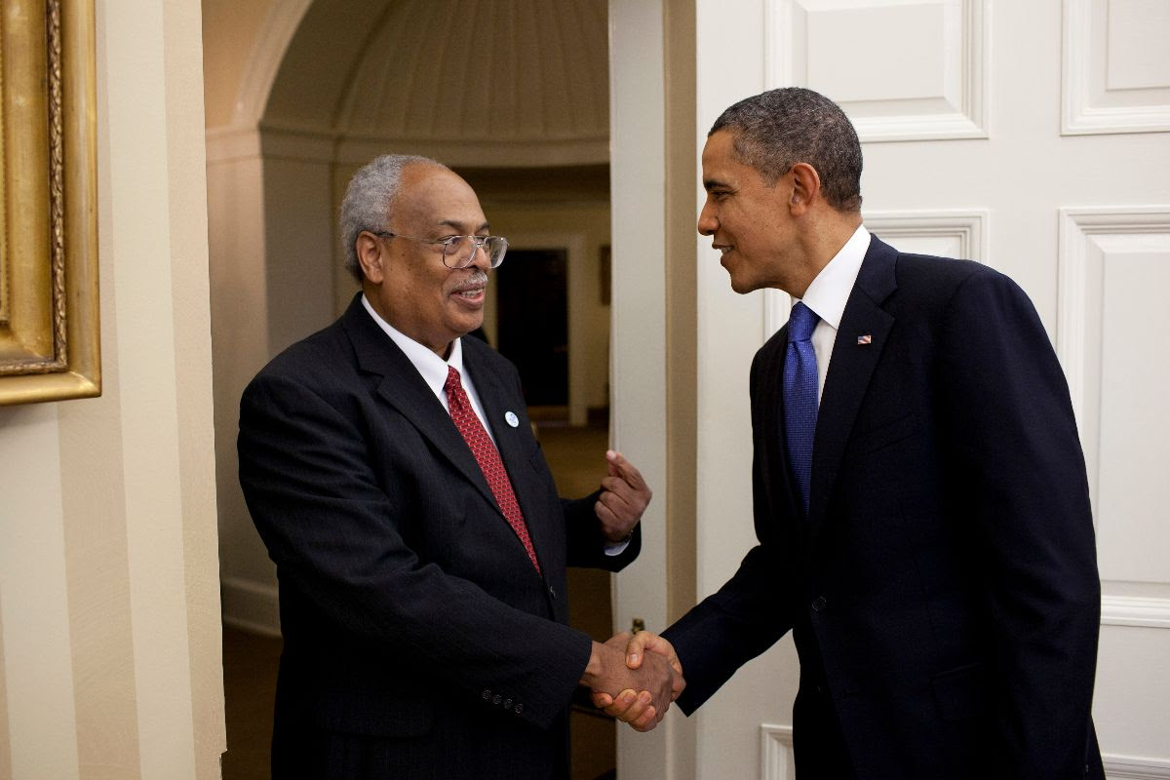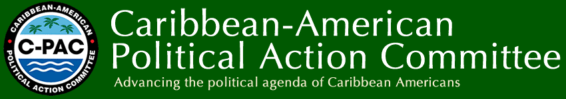
As we continue our celebration of Caribbean-American Heritage Month, we will be recognizing and honoring the life and work of Dr. Winston Anderson.
Dr. Winston Anderson came to the United States from Jamaica in 1958 to attend Howard University. It was at Howard that he was exposed to the Civil Rights Movement. This had a profound impact on him and influenced him to get involved in the struggle to empower Black people. He explained that he participated in the Freedom Rides to North Carolina and other Southern cities with Marion Barry, former Mayor of D.C. He was also influenced by Kwame Ture (formerly Stockley Carmichael), a fellow Caribbean national and a classmate.
“I was very lucky,” he said. “People of my generation were lucky to have been born Jamaican, because we were immersed in the history of the island, including the history of our heroes, freedoms and cultural enlightenments. And so, coming to Howard University, when the Civil Rights Movement was at its peak, I was influenced not only by my professors and other students, but by my upbringing as a Jamaican.”
Dr. Anderson graduated from Howard with a B.S. in Zoology in 1962 and a Master’s degree in Zoology in 1963. While at Howard, he won the Beta Kappa Chi Award for Academic Excellence. He went on to earn a PhD in Biomedical Science from Brown University in 1966. “I’m one of the lucky ones,” he said. “I came to this country to be a dentist. Along the way I decided I wanted to do research. I was lucky that I got a scholarship to Brown University. That really further encouraged me to go on to biomedical research.”
After graduating from Brown, Dr. Anderson served as an American Cancer Society postdoctoral fellow at the University of Paris for two years. He returned to the U.S In 1968. From 1969 – 1970, he was a post-doctoral fellow in the field of cell biology at Harvard University. He was also an instructor in Harvard’s Anatomy Department during that period. He then went on to teach at the University of Chicago Pritzker’s School of Medicine. In 1973 he became the youngest ever faculty member to be given tenure by the University. He also received the vaunted Anne Langer Award for Cancer Research for his study of breast cancer and uterine physiology, on which he published articles in several professional journals.
In the midst of his many successes, Dr. Anderson never forgot his roots. “That (the successes) were very good,” he said. “But after a while I had the urge to come back into a black or African American institution, such as Howard University.” He returned to Howard in 1975, where he served as the chair of the Zoology Department until 1984. Also, beginning in 1977, and for the next decade, Dr. Anderson directed the Life Science Careers for Minority High School Students in the United States. The program was funded by Howard University and the Rockefeller Foundation. It was a resounding success, providing summer research opportunities at sites around the country for over 800 participants. Of that number 70-80 percent eventually attended a college or university. Many went on to earn their PhDs under Dr. Anderson’s mentorship.
Dr. Anderson also oversaw other programs. One was supported by the Pew Charitable Trust, which recruited and trained more than 50 Washington-area students in science and mathematics at Howard labs. Thirty-five others were trained at the labs of Yale, Brown, and other universities. Through another program, Dr. Anderson helped to integrate the Marine Biology Laboratory at Woods Hole in Massachusetts.
Dr. Anderson’s work extended beyond the U.S. He was instrumental in setting up a program to train three hundred 9th and 10th grade teachers in Ethiopia. This was at the end of their civil war in the early 1990s. The program was funded by a grant from the Minority Health Initiative. The teachers were trained in both the arts and the sciences. Dr. Anderson noted that, “This was at the end of the war… and this helped Ethiopia to really invigorate its high school system, which was broken.”
For his groundbreaking work Dr. Anderson has been recognized by numerous organizations. He was honored by Brown University in 1992 with its Outstanding Graduate Alumnus Award and Howard University’s Division of Academic Affairs recognized him for establishing the distinguished lecture series, “Brilliant Encounters in Science.” In 2006, the Howard Hughes Medical Institute (HHMI), a non-profit medical research organization, presented 20 accomplished United States (U.S.) researchers from diverse fields, including genetics, biochemistry, plant pathology, bioengineering, neuroscience, biophysics and computational biology with a US $1 Million grant each. Dr. Anderson was recognized for his work. And in 2011, he was lauded by President Barack Obama with the Presidential Award for Excellence in Science, Mathematics, and Engineering Mentoring.
Amidst all these academic and professional accomplishments and honors, Dr. Anderson is most proud of his work developing the Sandy Spring Slave Museum and African Art Gallery, and a new project to restore a building associated with the Grand United Order of Odd Fellows in America.
The Museum was founded in 1988 when Dr. Anderson and his brother, Benard, purchased a plot of land in Sandy Spring an area that was the first community for free blacks in Montgomery County. Sandy Spring was also a stop along the Underground Railroad. The Museum now welcomes approximately 3,000 visitors annually.
The Lodge building was the only place where freed Blacks could have social activities. Dr. Anderson, along with a support team, have been renovating the building with a $500,000 grant from the State of Maryland. Dr. Anderson explained that, “We want to make this Lodge a center of social and cultural activity in this area. We want to install a theater group in this Lodge (and) we want to express a sense of Caribbean culture in this area.”
Through his work as a cell biologist and activist, Dr. Anderson has made educating members of the African Diaspora, and advancing their cause, among his main priorities. This is further evidenced by his support of the Caribbean Political Action Committee (C-PAC). “The mission of C-PAC is to endorse and support positions that would strengthen the political, economic, educational, and cultural conditions of individuals of Caribbean heritage,” he said.
Dr. Anderson is a founding member of the American Society for Cell Biology (ASCB) and the first African American scientist elected to serve on its Council. He is supported in his endeavors by his wife Carol and children, Laura, Lea and Michael.

